Kitty Litter Cake
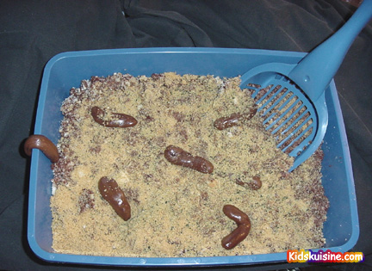

Over the years, no recipe has received as much press as this one has. This is actually a tasty cake that looks like a litter box
Kitty Litter Cake Serving Size:
This is a fun cake! It might look gross, but it does taste good! Ingredients:
1 (18 oz.) box spice or German chocolate cake mix
1 (18 oz.) box white cake mix
1 pkg. white sandwich cookies
1 large box vanilla instant pudding mix
12 small tootsie rolls
1 litter box (preferably a NEW one!)
1 plastic scoop
green food coloring
Preparation:
Prepare cake mixes and bake according to directions (any size pans).
Prepare pudding mix and chill until ready to assemble.
Crumble white sandwich cookies in small batches in blender, they tend to stick, so scrape often. Set aside all but about 1/4 cup. To the 1/4 cup cookie crumbs, add a few drops green food coloring and mix using a fork or shake in a jar.
When cakes are cooled to room temperature, crumble into a large bowl. Toss with half the remaining white cookie crumbs and the chilled pudding. You probably will not need all of the pudding, mix with the cake and “feel” it, you don’t want it soggy, just moist; gently combine.
Put mixture into clean litter box.
Put three unwrapped Tootsie rolls in a microwave safe dish and heat until soft and pliable. Shape ends so they are no longer blunt, curving slightly. Repeat with 3 more Tootsie rolls and bury in mixture.
Sprinkle the other half of cookie crumbs over top. Scatter the green cookie crumbs lightly over the top, this is supposed to look like the chlorophyll in kitty litter. Heat remaining Tootsie Rolls, three at a time in the microwave until almost melted. Scrape them on top of the cake and sprinkle with cookie crumbs.
Place the box on a newspaper and sprinkle a few of the cookie crumbs around. Serve with a new pooper scooper.
ENJOY

